 |  | 
SECRETARIAT GENERAL
-------------
DIRECTION GENERALE DE
L’ENVIRONNEMENT
-------------
DIRECTION DU CHANGEMENT
CLIMATIQUE
-------------

INCEPTION WORKSHOP REPORT
PHASE I and PHASE II

“Promoting Climate Resilience to the Rice Sector through
Pilot Investments in the Alaotra-Mangoro Region” project

INTRODUCTION
The Government of Madagascar, through the United Nations Environment Programme (UNEP) which is a Multilateral Implementing Entity of the Adaptation Fund, had submitted into the Adaptation Fund Board a project entitled “Promoting Climate Resilience to the Rice Sector through Pilot Investments in the Alaotra-Mangoro Region”. This project seeks to address vulnerability of the Rice sub-sector climate variability and projected climate change. The project will be piloted in the Alaotra-Mangoro region located on the Central Highlands of Madagascar. The overall objective of the project is to initiate the transformation of the Rice sub-sector to make it more resilient to current climate variability as well as expected climate change and associated hazards. It contains three components: 1- Scientific and Technical Capacity; 2- Adapted and Resilient Rice Production Cycle; and 3- Leveraging Policy Change.

The project inception workshop was held on 24 and 25 October 2012 in Ambatondrazaka. Given the importance of this project for the Government, high authorities of the Malagasy State was attended the project inception workshop, including the Prime Minister and the Minister of Agriculture. The presence of these high authorities was an opportunity to show them the reality on the ground of climate change impacts on rice sub sector and the pertinence of the project to address these impacts. The two days were devoted to speech, project presentation and visits of the three project sites. Therefore, we did not have enough time to discuss in detail with stakeholders the project activities. That is why, the Ministry of Environment and Forests (MEF) organized a second workshop on 17 and 18 December 2012, still in the inception workshop and the objective is to improve stakeholders understanding of the project and confirm project activities, outputs and outcomes . So there are two reports for this inception workshop, Phase I report and Phase II report

INCEPTION WORKSHOP REPORT

PHASE I

24th and 25th October 2012

Venue: Ambatondrazaka, Madagascar
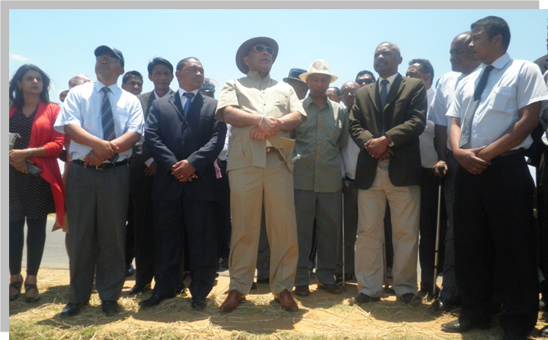
Photo; Prime minister of Madagascar (centre)
Table of Content
1. INTRODUCTION 1
2. OPENING CEREMONY 1
• Statement of Mr. Jacques Andriamanirison, Mayor of the Commune Urbaine d’Ambatondrazaka 2
• Statement of Mr. Lars Christiansen, UNEP Task Manager 2
• Statement of Mr. Stanislas Randrianatoandro, Secrétaire Général of the Région Alaotra-Mangoro 2
• Statement of His Excellency Mr. Mamy Ravatomanga, Minister of Agriculture 2
• Statement of His Excellency Mr. Jean Omer Beriziky, Prime Minister 3
3. PLENARY SESSION : Presentation of the project 3
4. VISIT OF PROJECT SITES
4.1 ILAKANA MANAKAMBAHINY OUEST (District of Ambatondrazaka) 3
4.2 ANONY AMBOHIJANAHARY (District of Amparafaravola) 4
4.3 BEMAINTSO ( District of andilamena)
5.BRIEFING ON THE ADAPTATION FUND PROCEDURES
6. CONCLUSIONS AND PERSPECTIVES 6

1. INTRODUCTION

The Ministry of Environment and Forests (MEF), had organized the inception workshop phase I for this project, on 24-25 October 2012 in Ambatondrazaka, the nearest city to the project sites.The main objectives of the workshop are to (i) inform and mobilize stakeholders at local and central levels on the project contributions to increase the resilience of the rice sub-sector, particularly by addressing climate change impacts; (ii) strengthen and facilitate local stakeholders’ understanding and support of project interventions; and (iii) confirm climate change issues and associated impacts that need to be addressed in the targeted region.
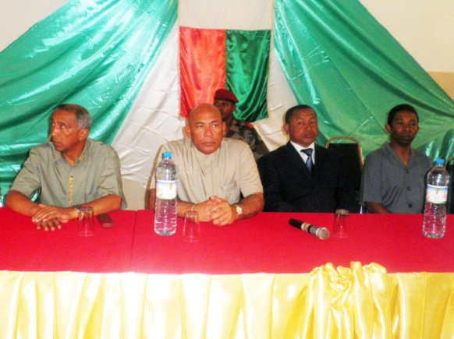
Officials during the opening ceremony. From left to right: H.E. Mr. M.Ravatomanga, Minister of Agriculture; H.E. Mr. J.O.Beriziky, Prime Minister and cartaker Minister of Environment and Forests; Mr. S. Randrianatoandro, SecrétaireGénéral of the Alaotra-Mangoro Region; and Mr. E.Rabenaivo from the District of Ambatondrazaka. Photo: MEF/DCC.
This report summarizes the activities undertaken during these two days of inception.

2. OPENING CEREMONY
Under the patronage of His Excellency Mr. Jean Omer Beriziky, Prime Minister, Head of Government and His Excellency Mr.MamyRavatomanga, Minister of Agriculture, the official opening ceremony was held on 24th October, 2012, at Espace Royal Club Ambatondrazaka.These two Malagasy Government members, the UNEP Task Manager, as well as two local authoritiesrepresentatives (the Mayor of the Commune Urbained’Ambatondrazaka, and the SecrétaireGénéral of the RégionAlaotra-Mangoro) had made statements during the official opening ceremony.

Statement of Mr.JacquesAndriamanirison, Mayor of the Commune Urbained’Ambatondrazaka
The Mayor of the Commune Urbained’Ambatondrazaka, Mr.JacquesAndriamanirison, welcomedalltheparticipants, particularly His Excellency Mr.Jean Omer Beriziky, to the city of Ambatondrazaka, which has the opportunity to be chosen for the implementation of this project. He stated that despite the political situation in the country, he hopes a successful implementation for the project.

Statement of Mr. Lars Christiansen, UNEP Task Manager
The UNEP Task Manager, Mr.LarsChristiansen, congratulated the Alaotra-MangoroRégion for being chosen among others, to host this important project. He also argued that Madagascar is yearly subject to extreme weather events related to current climate variabilitythat have severe impacts on its national economy. He then stated that the main goal of this project correspond to UNEP’s objective on sustainable development related with a sustainable environment. He emphasized the importance of stakeholder involvement, at central and local levels, fora successfuland effective project implementation. He closed his statement with a word of thanks to the Government of Madagascar for the collaboration between the UNEP and Madagascar.
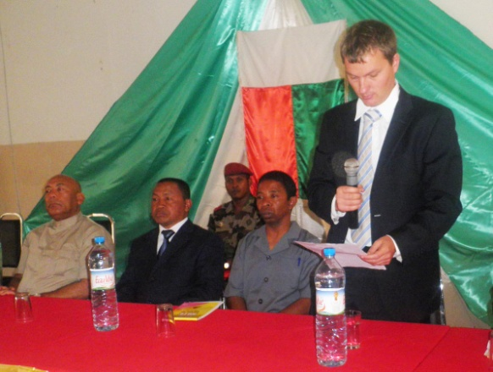
Mr. L.Christiensen, UNEP Task Manager, during his allocution on the official opening ceremony. Photo: MEF/DCC.

Statement of Mr.StanislasRandrianatoandro, SecrétaireGénéral of the RégionAlaotra-Mangoro
The SecrétaireGénéral of the Alaotra-MangoroRegionwelcomed the participants. He then thanked the Government and the project initiators for the choice of the targeted region. He also stated thatlocal stakeholders should take into account the advices from the central level technicians; and the project’s objectives will not be achieved without a close collaboration between these two entities.

Statement of His Excellency Mr.MamyRavatomanga, Minister of Agriculture
During his statement, the Minister of Agriculture re-affirms the importance of the project that will be implemented in the Alaotra-Mangoro Region, which is the national top rice producer. He encourages all stakeholders to maximally contribute to its implementation, which in turn will make the projectnot only a pilot initiative for Madagascar, but also for Africa. He emphasized theimportance of involvement stakeholders, at central and local levels, for the success and effectiveness of the project’s initiatives.

Statement of His Excellency Mr.Jean Omer Beriziky, Prime Minister of the Malagasy Government of Transition and caretaker Minister of Environment and Forests
During his statement, the Prime Minister indicated firstly the importance of this project due to rice’s crucial position in the national economy. After that, he said that the climate change is due to human activities, and is among the main threat to the agricultural sector including rice. He stated that innovative techniques and scientific research are needed to identify the appropriate measure that needs to be implemented. Finally, he calls for an inclusive collaboration between the local authorities and the project stakeholders for a successful implementation, and declare the workshop open.
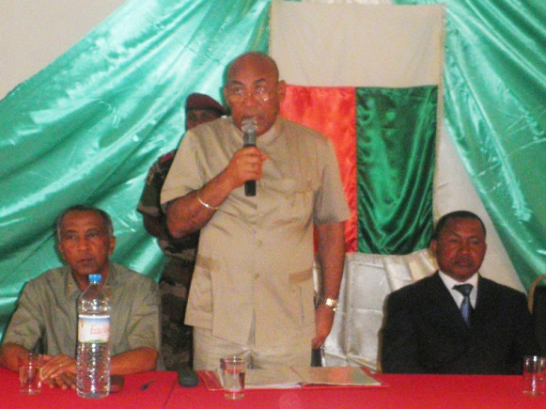
H.E. Mr. J.O.Beriziky, during his statement on the opening ceremony. Photo: MEF/DCC.

PRESENTATION OF THE PROJECT
Mr.Hery A. Rakotondravony, technical collaborator at the Climate Change Department (DCC) of the MEF presented the project.Thefollowing pointswerehighlighted: (i) project justification, the Rice sub-sector being extremely vulnerable to climate change but playing a central role on the national economy; (ii) main goal: sustainably increase rice yield despite the negative impacts of climate change; (iii) componentsoverview; and (iv) the choice of the targeted region.
During the presentation, the orator had reported that the project was extracted from national strategic document including NAPA and National Communications. He also argued that this initiative will serve as a pilot that will be replicated in other rice producing regions of the country. In addition, he said that the project will mostly deal with climate change impacts on the rice sub-sector; but that other measures to promote local communities resilience facing climate change willalso be addressed to obtain an optimal and successful implementation.

VISIT OF PROJECT SITES

THE ILAKANA MANAKAMBAHINY SITE

The visit of this site took place just after the official opening ceremony. All participants during the ceremony participated to the visit of the Ilakana site.
Ilakana (Commune Rurale[CR] de Manakambahiny) is localized 20 km south ofAmbatondrazaka, on the national road (RN) 44 between Ambatondrazaka and Antananarivo. All the visitors confirmed the importance of the project for the Ilakana site because of the advanced degradation of the arable surfaces due to erosion and siltation. The Regional Director of Environment and Forests explained the approximate Environmental conditionsof the land around Ilakana three to four decades ago, and the current situations: accelerated erosion and siltation; and change of the Ilakana river course after some part of it was totally silted during the last 10 to 15 years. The Director of Climate Change Department,Mr.Germain Randriasandratana, stressed the need of overall and effective involvement of local communities to avoid the repetition of the problems. The Mayor of the CR de Manakambahiny argued the necessity to reforest the hills surrounding the Ilakana site.
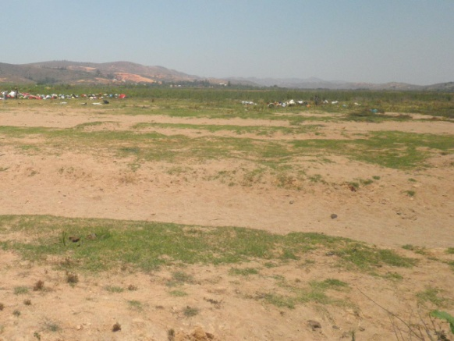
Silted arable land due to uphill accelerated erosion at Ilakana-Manakambahiny. Photo: MEF/DCC.

VISIT OF THE AMBOHIJANAHARY SITE
The visit of the Ambohijanaharysitetook place after lunch. The visitors were composed of Antananarivo delegations from the MEF, the Ministry of Agriculture and their respective regional representatives; national experts on Agricultural sector;UNEP, the Ministry of Water; and representatives of local authorities including the Chef duDistrictd’Amparafaravola.
This site is located in the west of Ambatondrazaka, approximately 80 km along the RN 44 and RN 3a, on asphalted roads.The trip offers the opportunity to appreciate how important is the Alaotra-Mangoro region for the Rice sub-sector, based on arable land areas.
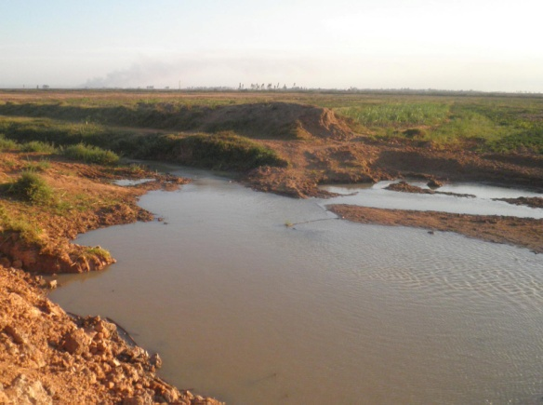
Irrigation infrastructure at Anony (Ambohijanahary) broken by a cyclone strike and flooding in 2009. Photo: MEF/DCC.
The Mayor of the CR d’Ambohijanahary had welcomed the visitors and thanks the Government and the donor for the investments that are to be undertaken in the CR d’Ambohijanahary. After that, he had mentioned the most important environmental threats facing Rice sub-sector in the surrounding areas: unpredictable change in rainfall regime, accelerated erosion and siltation, decreased soil fertility, and increased flooding. He told also that an important irrigation infrastructure at Anony (6 km from the Ambohijanahary village) was broken by a cyclone strike and flooding in 2009 and is not yet rehabilitated.
The DirecteurGénéraldel’EnvironnementofMEF, Mme Edmée C. Ralalaharisoa, thanks the Mayor of Ambohijanahary and the local communities at Anony for their hospitality. She indicated that the main benefits of the project will be for the local stakeholders, and she asked for an inclusive collaboration with local stakeholders for a successful project implementation.

4.3 VISIT OF THE BEMAINTSO SITE
On 25 October, the site of Bemaitso (District of Andilamena) was visited. The participants were composed of Antananarivo delegations from the MEF and the Ministry of Agriculture and their respective regional representatives; two national experts on Vulnerability and Adaptation, Agricultural sector; and one participant from the Ministry of Water.
Andilamena is situated 65 km north of Ambatondrazaka, at the end of the RN 44, on a secondary road. This trip offers the opportunity to observe the environmental problems facing the Lake Alaotra, one of Madagascar’s Ramsar site, and surrounding areas: deforestation, erosion and siltation, human pressures on natural forests and mineral resources, wild fires, etc.
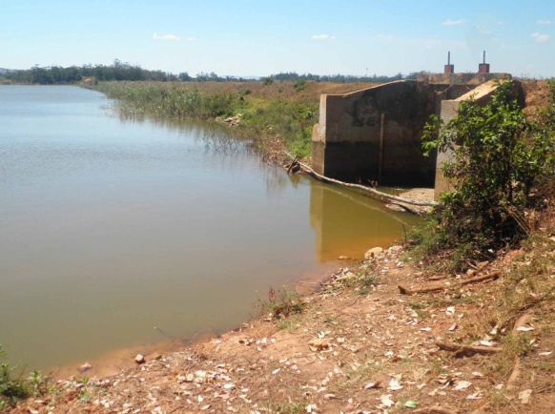
The Bemaitso dam at Andilamena. Originally, its deepest part is at more than 7 meters below water level. Uphill accelerated erosion during the last two decades lead to the fact that any part of the dam cannot exceed more than 3 meters deep. Photo: MEF/DCC.
The Bemaitso site is located approximately 10 km north of the Andilamena town, along a secondary road that is surely impassable during rainy season. The visitors were received by two persons, the head of BemaitsoCooperatives and the head of Water User Associations.
After their welcome words to the visitors, they directly evoked the environmental challenges facing rice cultivation for this site:
- uphill accelerated erosion leading to the siltation of the Bemaitso dam that need to be rehabilitated;
- unpredictable rainfall regime and drought; and
- newly emerging rice diseases during the last three to five years, which may provokeup to 80% production losses, and that need to be monitored and scientifically investigated (principally white borer and an unclear fungi/virus disease).
These representatives of local producers reported that more than 60% of the cultivators are practicing the “Système de RizicultureAméliorée (SRA)”. Also, they stated that the “Système de Riziculture Intensive (SRI)” are not widely accepted because it is highly time consuming and requires an excellent ability to manage water resources. They signaled that most producers adopt actually some selected seeds such as “hybrid”, “tsemaka”, “MK mailaka”, etc.
The DirecteurGénéral de l’Environnementof MEF thanks the local authorities and communities for their hospitality. She indicated that the main benefits of the project will be for the local stakeholders, and she asked for an inclusive collaboration with local stakeholders for a successful project implementation.

BRIEFING TO PROJECT MANAGEMENT UNIT (PMU) ON ADAPTATION FUND PROCEDURES
A short briefing on the Adaptation Fund Procedures was conducted by the UNEP representatives, Ms.ShakiraKawaja and Lars Christiansen, in the evening. Among other things, the following issues were covered:
- Project Cooperation Agreement (PCA) including full clarification of all agreements including terms and obligations of both MEF and UNEP;
- Procedures of AF Board for an AF funded-project;
- Procurement policies and reporting requirements for AF projects, including presentation and discussion of the UNEP supervision plan.
- Project Management Unit issues, including:banking and financial transfer arrangements;opening of an AF project account;nationalprocurement policies & plans; Work plan for 2013; status and plan for appointment of PMU staff and plans for conduction of stakeholder workshop (see below).

6. CONCLUSIONSAND PERSPECTIVES
The presence of His Excellence Mr Jean Omer Beriziky, Prime Minister, Chief of the Government of Madagascar and His Excellence Mr MamyRavatomanga, Minister of Agriculture and other eminent personages to the project inception workshop shows the importance the Government attaches to this project given the place that rice growing occupies in the food of the malagasy people and in the national economy:

This situation also explains the engagement of the Government to carry out this project thus facilitating its acceptance by the authorities and local communities as well as the integration of the latter in its implementation.

In addition, this workshop allowed the participants and the local authorities to express what they expected from this project and to thank the Government for having chosen Ambatondrazaka for the realization of the project and UNEP for its assistance and its presence on the site.

Currently, the MEF is preparing a workshop aiming at confirming the activities of the project and eventually collecting other points of view from local actors in order to improve project activities and to facilitate their implementation. This workshop will be held in Ambatondrazaka on December 13rd and 14th 2012.

.ANNEX I :PROGRAMME FOR THE INCEPTION WORKSHOP
Date | Time | Content /Ressource
October-24th-2012 | 08H30- 09H30 | Registration
October-24th-2012 | 09H30-10H:am | Opening Ceremony
October-24th-2012 | 09H30-09H35:am | Welcome words by the Mayor of Ambatondrazaka
October-24th-2012 | 09H35-09H40:am | Opening Remarks by the Secretary General of AlaotraMangoro
October-24th-2012 | 09H40-09H45:am | Statement by UNEP Task Manager, Mr. Lars Christiansen
October-24th-2012 | 09H45-09H50am | Statement by HE Mr Ravatomanga Rolland, Minister of Agriculture
October-24th-2012 | 09H50-10Ham | Opening Statement by HE Mr Omer Beriziky, Prime minister
October-24th-2012 | 10H-10H0:am | Presentation of the Project
October-24th-2012 | 1030-11H00:am | Coffee/tea/ break
October-24th-2012 | 11H00-13H00:am | Visit of the first project site ( Ambatondrazaka)
October-24th-2012 | 13H00:am- 14H30:pm | Lunch
October-24th-2012 | 14H30:17H30:pm | Visit of the Second project site (Ambijanahary/ Amparafaravola)
October 25th-12 | 08H30:am- 16H30:pm | Visit of third project site ( Andilamena)

Annexe II: List of Participants
N | Name | Institute | Position
01 | BERIZIKY Omer | Primature | Prime Ministre
02 | RAVATOMANGA Rolland | Ministry of Agriculture | Minister
03 | RAKOLOLAHY Charles C.S | Primature | Director of Cabinet
04 | RANDRIANATOANDRO Stanislas | Region AlaotraMangoro | Secretary General
05 | RALALAHARISOA Christine | Ministry of Environment | General Director
06 | ANDRIAMANIRISON Jacques | District Ambatondrazaka | Deputy Chief of District
07 | RABENAIVO E. | District Aparafaravola | Chief of District
08 | ANDRIAMAINTY Fils Jean Maurice | District Andilamena | Chief of District
09 | RASOLONIRINA Ramenason | DREF AlaotraMangoro | Director
10 | RakotobeNirhy | DRDR AlaotraMangoro | Director
11 | RASOLOFO Louis Stella | Commune of Andilamena | Mayor
12 | RABEARISON Sarindraniaina Luc | Direction of Communication | Director
13 | Jacque Andriamanirison | Commune of Ambatondrazaka | MAYOR
14 | RANAIVOSOLO | Commune of Andilamena | Deputy MAYOR
15 | RAkotomaharoHaingo | Direction of Communication | Director
16 | RabetokontanyJeriniaina | DRDR AlaotraMangoro | Collaborator
17 | BeraArisaona | Direction of Pollution Management | Director
18
19 | RAKOTOMAHARO Haingo | Direction of Communication | Collaborator
20 | RanaivosonFameno | Direction of Meteo | Chief service
21 | Razafindrakoto Benjamin | FOFIFA | Collaborator
22 | AURELIE | DGTAAmbatondrazaka | Representative of DGTA
23 | Rabeson Raymond | FOFIFA | Expert
24 | RandriasandratanaGermain | Direction of Climate Change | Director
25 | Raholiarivony Julia | Direction General of Environnement | Collaborator
26 | RakotozafyHarimisa | Ministry of Environment | Collaborator
27 | Ramahavalisoavalerie | Directorate of information and communication | Collaborator
28 | LalasonAiméMarcellin | Direction of Climate Change | Collaborator
29 | Mara Edena | Direction of Climate Change | Collaborator
30 | HeryRakotondravony | Direction of Climate Change | Collaborator
31 | TahiryLalaina | Direction of Climate Change | Collaborator
32 | Lars Christiansen | UNEP | Task Manager

INCEPTION WORKSHOP REPORT
PHASE II

“Promoting Climate Resilience to the Rice Sector through
Pilot Investments in the Alaotra-Mangoro Region” project

Date: 13th and 14th December 2012
Venue: Ambatondrazaka, Madagascar
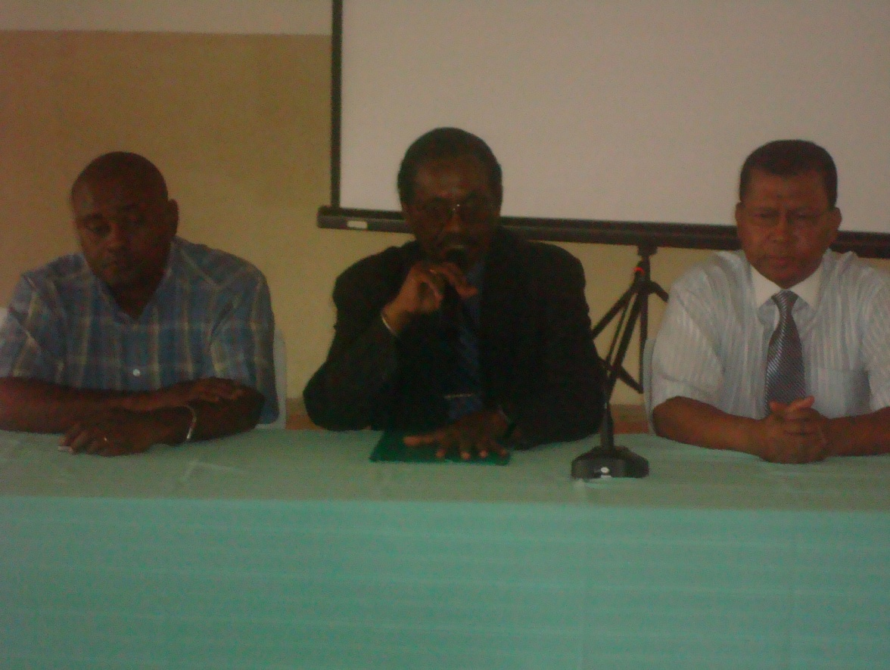

Table of Contents

ACRONYME……………………………………………………………………………………………………….3
- INTRODUCTION………………………………………………………….............................4
- OPENING REMARKS ……..……………………………………………………………………… 4
- PLENARY SESSION 1
  - Presentation of the Project…………………………………………………………4
3.2 Session of Questions/Responses……………………………………………….5
4. PLENARY SESSION 2; Group discussions
4.1 Recommendations on project logical framework ……………..………7
4.2 Recommendations on project first year work plan …..…..…………. 8
5- CLOSINGREMARKS..……………………………………………………………………………10
ANNEXES
Annexe 1:Agenda
Annexe 2: Lists of participants
Annexe 3: Five years Work plan
Annexe 4: Budget

ACRONYMES
DRDR: Regional Directorate of Rural development
MINAGRI: Ministry of Agricultural
MINEAU: Ministry of water
AUE: Association of Water User

- INTRODUCTION
After the launching workshop of theproject «Promoting resilience of rice sector to climate change in the region of Alaotra Mangoro"during which we could not achieve as expected the workshop’s target to discuss with the participants the project activities, the Ministry of Environment and Forests organized a two-day workshop on 13rd and 14th December 2012 at Royal Hotel, Ambatondrazaka.

The purpose of the workshop was to improve the understanding of the project and to confirm the related activities.

The workshop was attended by local authorities(Region,District,Commune,Fokontany), the decentralized Services (Regional Directorate of Agriculture,Regional Directorate of Environment and Forestry, Regional Directorate of Water), the associations of water users in the three project sites and representatives of government departments at the central level (Ministry of Agriculture, Ministry of Water, Ministry of Environment and Forests,national Research Centre on Agriculture,national Experts on the adaptation of agriculture to climate change impacts).

2. OPENING CEREMONY
After welcoming all the participants and thanking them for their attendance at the workshop, Mr.Germain Randriasandratana, Director of Climate Change (DCC), explained the reasons of the postponement of the workshop. Indeed, the presence of the Prime Minister and the Minister of Agriculture was an opportunity to show them the reality in the field regarding the impacts of climate change on rice and the relevance of the project. Thus, there was not enough time to discuss in detail the project activities and to know the respective opinions of the participants about the project
After that, the representative of the Head of the Region AlaotraMangoro, Mr.Razafindramanitra Daniel Christophére, Director of Administrative and Territorial Management welcomed all the participants and thanked the Government of the important initiative to reduce the impacts of Climate Change on rice growing. He encouraged the participation of the communities and technicians at all stages in order to develop a new policy on rice at the same time taking into account climate change and reaching the development of the region.

3. PLENARY SESSION 1
3. 1 Présentation of the project
Ms Jane Razanamiharisoa, Head of Department of Adaptation to Climate Change Effects made ​​a detailed presentation of the project. She first presented an overview of the project, mentioning the project sites and the reasons for their selection, the cost and duration of the project, the technical and financial partners, in particular UNEP, which plays the role of the implementing entity of the Adaptation Fund in the project. Then, she talked about the background of the project, the project’s objectives, its components, outcomes and outputs and the various related activities of the project.

3-.2 Questions and answers session
Theproject presentationwas followed by a session of questions andanswersduring whichparticipants made ​​commentsand recommendations. The questionscould be answered inthe project documentbut it was necessary to add some explanationsfora better understandingof the activities, which will be undertakenunder theproject.
Some questionsasked:
Doesthe projecttake into accountthe existence of theNational Policyof Rice growing?
How does the projectconsider themanagement, the rehabilitation, and the construction of rice growing infrastructure, which is themajor problemof ricein the region?
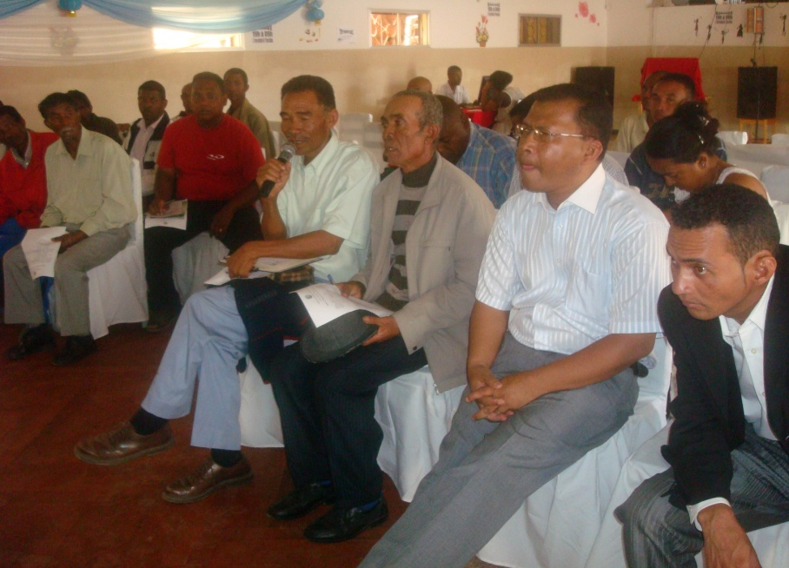
Question/answers session

It seems that mostofthe problems mentionedand recognizedontherice matter are not related to climate change.How do you explainthis situation in relation tothe objective of the project?
We would like tostrengthen the organizationsfor the water management (Water Users Association, Federations, etc...), what does the project can do to supportthe
functioning of these organizations
We hope thatthe project will generateincome activitiesfor local communities in the
region
Summary of answers to the above questions
TheNational Policyon Rice growingis one of the targets of the project. This National policy is taken into account with the third Component of the project ‘’leveraging policy change on rice subsector’’. We need to incorporate climate change in the policy of rice subsector.
The problem related to the construction and rehabilitation of rice growing infrastructure is considered by the project through its second component. The Project will support the rehabilitation of degraded irrigation and drainage infrastructure as well as the construction of new water storage facilities where necessary. This will be accompanied by measures to promote sustainable water management and conservation.
Most of problems mentioned and recognized on rice sector in the region are not related to climate change, but these factors or problems contribute enormously to the vulnerability of rice sector to climate change and therefore, we need to tackle of these factors in order to achieve the project objective.
4. PLENARY SESSION 2
4.1 .Working group
In the afternoon, participants weredivided into four workinggroups, one group for each project component and a fourth group forthInstitutionalArrangementissue.
The first threegroups were asked to focus ontwo documents: logical framework andwork planfor the firstyear. They were requested toshare their opinions on theproject activities, if theyreflect the realitiesand respondto theirexpectations, and if not, to propose changes. It is the same for the workplan; theparticipants gave their opinionsand madeproposalsin casethey did not agree with thetiming preset.
As for the fourth group working on the institutional arrangement, participants wereaskedto(i) describe the existing institutionalarrangementunderrice growingthe region andparticularly atthe project sites(ii) identifyweaknesses andstrengths to these arrangements, and (iii) to suggest improvements in the institutional arrangements that could improve the chances of project success.
4-2 Recommendations on project outcomes,outputs, activities and indicators
Group 1:Scientific and technical capacities
Outputs :The group emphasized on technology to be selected and validated in order to reflect really the need of the region.
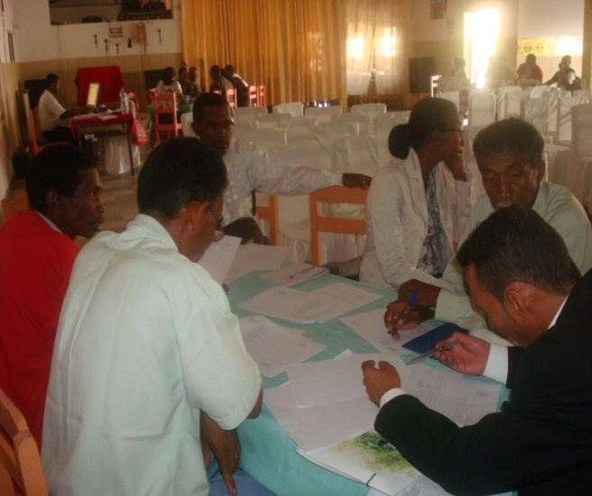
Activities :The group underline the importance of some activities mentioned in the first component : assessment through existing data , Identification of constraints , Identification of experts , Installation / rehabilitation of meteorological stations
Indicators: the group suggested to add as indicators: Number of validated technical for recipients and participants, a test of adaptability in other regions, at least 10 themes of training are identified, at least 100 people per site are chosen to follow the training, at least 10 experts are identified, one meteorological station operational

Groupe 1 on Scientific and Technical capacities
Group 2: Resilient and adapted rice production cycle

Activities: The group recommended to add in the component 2 the following activities: research of adapted seeds to landquality, alternationof cultures, improvement of arable lands using new techniques, adoption of incentive approach and method for local community to tackle concerns regarding watershed protection.
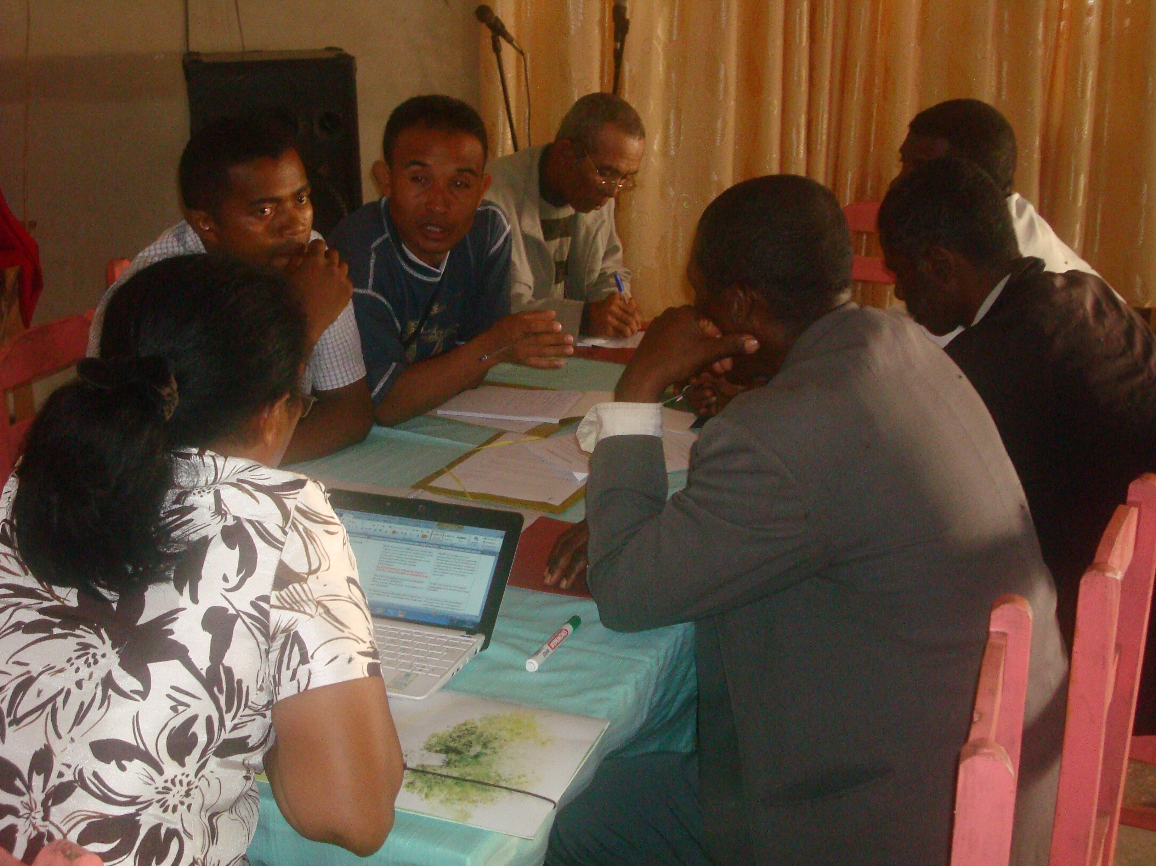

Groupe 2 on resilient and adapted rice production

Indicators : It is suggested to add as indicators : At least 5 rice varieties tested and proved resilient in the laboratory and under land conditions, superficie of restored watershed, 400 trained farmers on integrated pest management, 3 water tanks and infrastructures rehabilitated and supplied.
Group 3: leveraging the change of policy
The group didn’t have any recommendation on that component
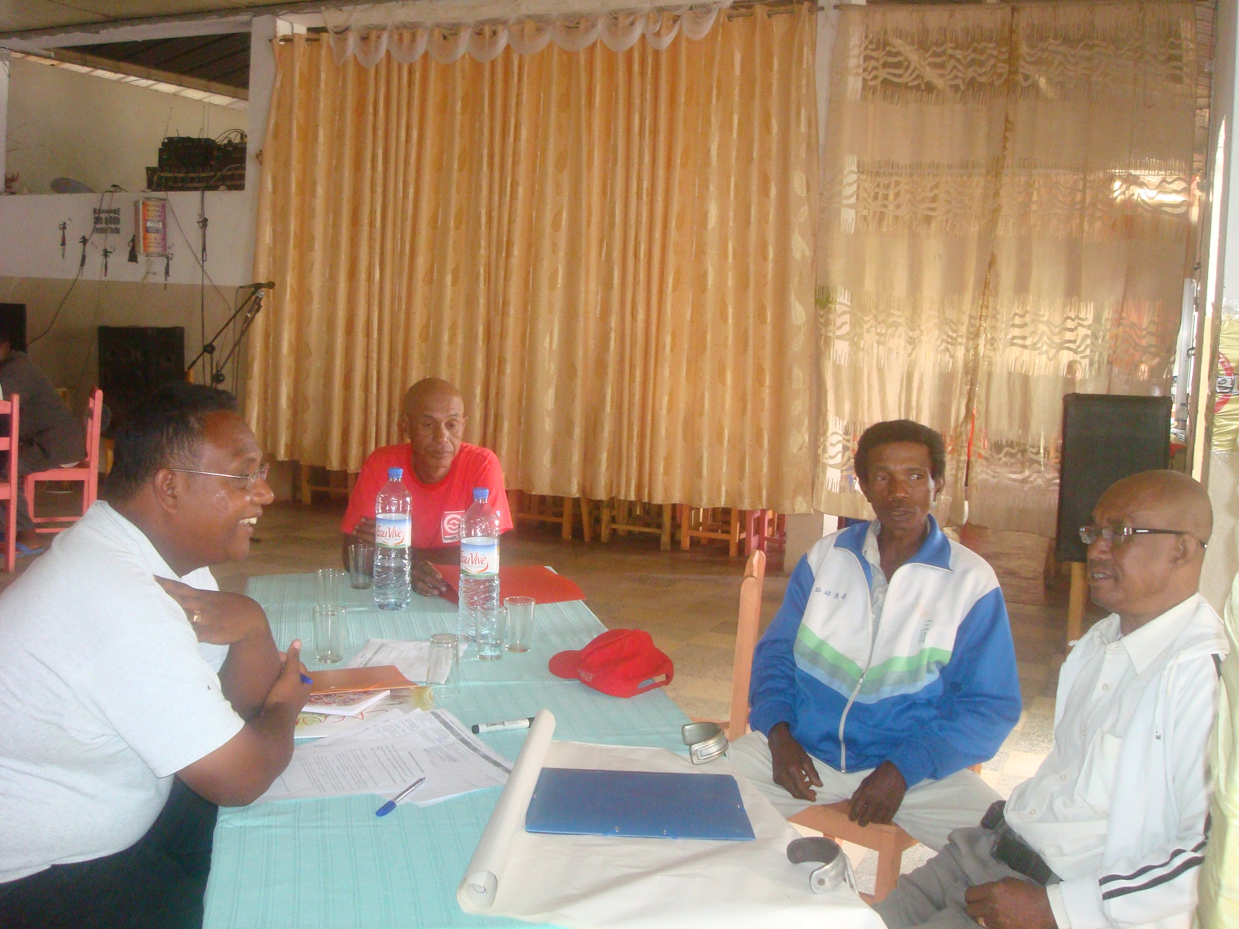

Group 4: Institutional arrangement

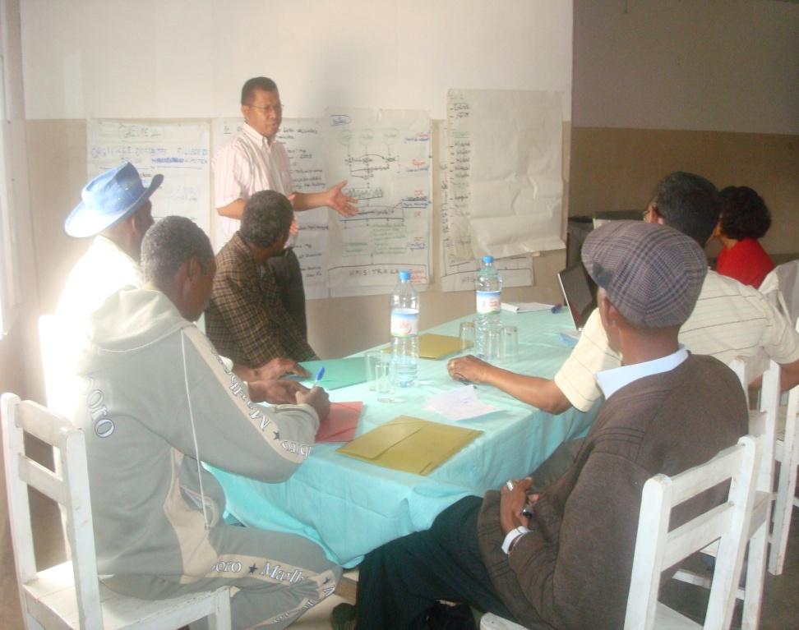
Group 4 on Institutional arrangement

The group has focused its work on three points:
- Description of the existing structure which is in charge of the rice sub sector in the
region
- Identification of strengths and weakness of this structure
- Improvements to be brought to this existing structure to facilitate the achievement of
the projectobjectives .
The group suggested to integrate others institutions in the management of the riziculture in the region. Indeed, the existing structure shows that only the DRDR (DirectionRegionale pour le DeveloppementRural ) cope with this sub sector and it is recommended that DREF (Direction Regionale de l’Environnement et des Forets) and DIREAU (Direction Regionale de l’Eau) should be integrated in the structure to be set up

The MEF took note of the many good and interesting suggestions made by the groups and will do its best to accommodate the views expressed in the implementation of the project. As needed and feasible, changes to project outcomes, outputs, activities and indicators will be discussed and approved by the PSC".

4-3 recommendations on first annual work plan
Based on the log frame and the proposed work plan, each group recommended the following first annual work plan for each component:
Group 1: Technical and scientific capacity
OUTPUTS | ACTIVITIES | CHRONOGRAM
OUTPUTS | ACTIVITIES | Q1 | Q2 | Q3 | Q4
Output1:  Best Available Technologies and Integrated Resilient Rice Model (MIRR) selected and publicized | 1. Undertake a participatory comparative analysis of rice production techniques and technologies available in relation to their resilience and cost-effectiveness |  | X
 | 2. Organize a seminar of on resilient rice model (MIRR) |  | X
 | 3. Publishtechnical guidelines for MIRR |  | X | X
Output 2:  Crop models are available for rice vulnerability mapping | 1. Acquire software and deliver training sessions on ORYZA 2000 (10 staff at central level) |  | X
 | 2.Perform data collection for DSSAT and  Oryza model population |  |  | X
 | 3.Develop and publish to alternative models, using DSSAT and Oryza for 2050 and 2100 for the region |  |  | X
 | 4 Develop a climate based hydrological model for the Alaotra region for 2050 and 2100
Output 3:  Uupdated, dynamic agricultural calendars and climate early warnings taking into account current and projected variability disseminated to local population | 1 Adapt and disseminate agricultural calendars in relation to new climate trends and data, as per agreed methodology
 | 2 Acquire , install and operate climate and hydrological monitoring equipment for early warnings
 | 7.Ensure the transmission of climate and weather bulletins through radio.
Output4:  Agricultural extension staff trained on climate risk management in an agro-ecosystem context. | 1Climate Risk Management and agro-ecosystem approach training for decentralized personnel

Group 2: Adapted and resilient rice production cycle

OUTPUTS | ACTIVITIES TO BE IMPLEMENTED | CHRONOGRAM
OUTPUTS | ACTIVITIES TO BE IMPLEMENTED | Q1 | Q2 | Q3 | Q4
Output 1:  Climate resilient varieties selected through participatory field testing | 1.Pre-select adapted varieties among existing strains |  |  | X
 | 2.Procure inputs and materials (seeds, tools) |  |  |  | X
 | 3.Perform participatory field test of the adapted varieties in relation to identied climate stresses.
 | 4.Monitor the participatory variety selection programme over 2 seasons. |  | X
Output 2 :  An operational multiplication and dissemination scheme for adapted seed varieties | 1.Participatory variety selection validation (from a shortlist of resistant varieties
 | 2.Production of pre-base and foundation seeds
 | 3.Multiplication and distribution of certified seeds
Output 3:  Uupdatedfertilization guidelines according to best available standards and taking climate conditions into consideration | 1.Update fertilisation formulas, guideline and packets using climate change and MIRR models, considering socio-economic aspects |  |  |  | X
 | 2.Use locally available fertilizer (ex. compost, manure, agricultural residues, including rice straws and by products
Output4:  Integrated pest management is implemented | 1.Implementationof Integrated Pest Management Best Practices |  |  | X | X
Output 5:  Water efficiency, management and conservation technologies and infrastructures are implemented | 1.Rehabilitation of damaged gravitational irrigation infrastructure and canals |  |  |  | X
 | 2.Clearing-out of the water reservoirs silted up |  |  |  | X
 | 3.Installation of new irrigation, drainage and water conservation structures |  |  |  | X
 | 4.Implementation of irrigation and water conservation (including water harvesting) practices adapted to new climate and conditions with related training of water.
Output 6 :  Best available land preparation, production and harvesting techniques disseminated to reduce deforestation, maintain soil fertility and integrity, and to provide adequate growing conditions | 1.Implement Integrated Resilient Rice Model (MIRR) for production | X
 | 2.Introduce rice-vegetable rotation systems using disease resistant, water efficient reslient crops (leafy vegetables, legumes)
 | 3.Develop and distribute technological packets and information documents
Output 7:  Watershied management and rehabilitation in productive landcscape introduced, including through reforestation, wetlands restoration and protection | 1 Participatory Revegetation of degraded slopes and forests, using multi-purpose resilient trees, grasses (vetiver) and participatory management of forests resources
 | 2 Training on sustainable agroforestry and landmanagement (including in a climate change context)
Output 8 :  Soil conservation and livestock  management techniques adapted to topography and landscape in light of future climate conditions | 1 Adaptation and reintroduction of soil conservationmethods for erosion control (tillage, sedimentbarriers, mulching) in upland and lowland uses
 | 2 Training on the sustainable land use of inactive orstage 2 lavakas and tanety agriculture (for uplandcommunities)
 | 3 Assessment of resilience in livestock managementwithin rice cultivation systems and adaptation ofpractices for resilience, erosion control, andincreased productivity
Output 9:  Revitalization of producer’s cooperatives and water user associations for collaborative natural resources allocations (e.g land and water) and management | 1.Training, legal support and provision of administrative means for producers cooperatives and water user associations
Output 10:  Water quality monitoring and management is introduced locally for disease vector control | 1.Introduce local level water quality monitoring methods |  | X | X | X
Output 11 :  Increased utilization of rice by-product especially rice straw | 1.Introduction of the techniques and technologies for the use of rice straws in animal feed and for energy production
Output 12:  Post-harvest storage facilities with phytosanitary control, serving as trading points and markets | 1.Rehabilitation of storage facilities using upgraded phytosanitary and climate resilience norms on basis of an inventory |  |  | X

Groupe3 :Leveragingpolicychange
OUTPUTS | ACTIVITIES | CHRONOGRAM
OUTPUTS | ACTIVITIES | Q1 | Q2 | Q3 | Q4
Output 1:  Gaps and possible maladaptations in the current rice policy are identified and recommendations on rice policy reform are made | 1.Create a multi-partner and interministerial task form on rice resilience, including government, NGOs, private sector and local representatives)
 | 2.Develop recommendationson the rice sector transformation and propose a rice policy
Output 2:  A report on best practices and lessons learned for rice adaptation in Madagascar | 1.Engage a dialogue on the socio-economic conditions required for project sustainability.
 | 2.Identify local best practices in the three sites of intervention
 | 3.Develop contract with the local financial institutions.

5. CLOSING REMARKS
In closing the workshop the representative of the Region thanked all the participants for their active participation. He thanked particularly the MEF team for organizing this workshop, which help them to well understand the project and to make some suggestions in order to improve it.. He encouraged every body to work together to achieve the project objective. He also thanked GEF and UNEP for their assistance making this project possible. Withthis, he declared the workshop closed and finally

ANNEXE I: AGENDA
DATE | TIME | THEMES
December 13rd .2012 | 09H00-09H30 | Registration
December 13rd .2012 | 09H30-10H00 | Opening ceremony
December 13rd .2012 | 10H00-10H30 | Presentation of the project
December 13rd .2012 | 10H30-10H45 | Coffee-break
December 13rd .2012 | 10H45-12H30 | Questions /Answers
December 13rd .2012 | 12H30-14H30 | Lunch break
December 13rd .2012 | 14H30-17H00 | Group work
December 14th. 2012 | 09H00-12H00 | Group work
December 14th. 2012 | 12H00-14H00 | Lunch
December 14th. 2012 | 14H00-15H30 | Restitution
December 14th. 2012 | 15H30-16H00 | Closing remarks

ANNEXE II: Lists of the participants
N | Name | Institute | Position
01 | Razafindramanitra Daniel Christophere | Region of AlaotraMangoro | Director
02 | RaherinjanaharyAndriamparany | District Amparafaravola | ChiefDistrct
03 | Randriasandratana Germain | Directorate of climate change | Director
04 | RakotobeNirhy | Regional Direction of Rural Development | Director
05 | Ravelonahanitrininosy | Federation of Ambohijanahary | cultivator
06 | Ratsihavana Daniel | Commune of west MANKAMBAHINY ( Ilakana | Mayor
07 | Randriamiarina Jean Claude | Commune of west MANKAMBAHINY | cultivator
08 | Ratsiarina | FokontanyMiaramanjaka | Chief of Fokontany
09 | Randriamahafalisoa Gabriel | FokontanyAmbohidehilahy | Chief of Fokontany
10 | RasamimananaMasindraibeHerytina | Federation of soamaharitra West m/hitsy | Responsible of federation for managing
11 | Rakotonirina Samuel | Federation of fokontanyMiaramanjaka | Deputy President
12 | RandriamandimbySylvestre | Federation Madimbisoa,Miaramanjaka | Secretary
13 | Rabetokontany Gilbert | Commune Ambohidehilahy | cultivator
14 | Randriamarolahy Gilbert | Federation of Mandimbisoa and Miaramanjaka | President
15 | Ratsimbazafy Jean Pierre | Expert in Agricultural | Expert in Agriculture
16 | Ravelonkasina Dina | Regional Direction of Environment and Forest | Colaborator
17 | RamanamisataNantenaina | Regional Direction of Environment and Forest | Regional Direction of Environment and Forest
18 | RakotoharisoaHerizoaLalaina | FOFIFA/CALA | Collaborator
19 | HasinaRanaivojaona | Ministry of Water | Technical Staff
20 | RajaonahNirina | Miistry of Agricultural | Technical Staff
21 | BetokontanyJeriniaina | Regional Direction of Rural development | Technical Staff
22 | RandriamanjakavolaEdouard | Commune Ambohijanahary | Cultivator
23 | Randimbiharimanana Victoria | Commune Ambohijanahary | Cultivator
24 | LalasonAiméMarcellin | Direction of Climate change | Technical Staff
25 | Razanamiharisoa Jane | Direction of Climate change | Chief of Adapatationservice
26 | HerilalainaTahirinjanahary | Direction of Climate change | Colaborator
27 | Randriamila Armand | Commune Bemaitso | Mayor
28 | Randriambola | Member of AUE MandrosoBemaitso | Cultivator
29 | Ranarivony Marcel | Federation TsimolahyAmbohijanahary | President
30 | Razafindrakoto Charlotte | FOFIFA/CALA | Director
31 | RandriamalalaRodolphe | Commune Ambohijanahary | Mayor

ANNEXE III: FIVE YEARS WORK PLAN

COMPONENT | OUTPUT | ACTIVITIES | CHRONOGRAM |  |  |  |  |  |  |  |  |  |  |  |  |  |  |  |  |  |  |  | RESPONSABLE
 |  |  | 2013 |  |  |  | 2014 |  |  |  | 2015 |  |  |  | 2016 |  |  |  | 2017
 |  |  | Q1 | Q2 | Q3 | Q4 | Q1 | Q2 | Q3 | Q4 | Q1 | Q2 | Q3 | Q4 | Q1 | Q2 | Q3 | Q4 | Q1 | Q2 | Q3 | Q4
PROJECT INCEPTION | Official and effective launching of the project | Organization of project inception workshop | X |  |  |  |  |  |  |  |  |  |  |  |  |  |  |  |  |  |  |  | MEF
PROJECT INCEPTION | Official and effective launching of the project | Setting up of PMU | X |  |  |  |  |  |  |  |  |  |  |  |  |  |  |  |  |  |  |  | MEF
PROJECT INCEPTION | Official and effective launching of the project | Purchasing of equipment and informatics materials |  | X |  |  |  |  |  |  |  |  |  |  |  |  |  |  |  |  |  |  | PMU
PROJECT INCEPTION | Official and effective launching of the project | Recruitment of STA and Consultant for baseline study | X | X |  |  |  |  |  |  |  |  |  |  |  |  |  |  |  |  |  |  | PMU-UNEP-Agric
SCIENTIFIC AND TECHNICAL CAPACITY | Best Available Technologies and Integrated Resilient Rice Model (MIRR) selected and publicized | Undertake a participatory comparative analysis of rice production techniques and technologies available in relation to their resilience and cost-effectivenes |  | X |  |  |  |  |  |  |  |  |  |  |  |  |  |  |  |  |  |  | national rice experts
SCIENTIFIC AND TECHNICAL CAPACITY |  | Organization of a seminar on resilient rice model (MIRR) |  | X |  |  |  |  |  |  |  |  |  |  |  |  |  |  |  |  |  |  | international rice experts; national agriculture and rice experts
SCIENTIFIC AND TECHNICAL CAPACITY |  | Publish technical guidelines for MIRR |  | X | X |  |  |  |  |  |  |  |  |  |  |  |  |  |  |  |  |  | internationalrice expert
SCIENTIFIC AND TECHNICAL CAPACITY | Crop models are available for rice vulnerability mapping | Acquire software and deliver training sessions on Oryza 2000 (10 staff at central level) |  | X
SCIENTIFIC AND TECHNICAL CAPACITY | Crop models are available for rice vulnerability mapping | Perform data collection for DSSAT and Oryza model population |  |  | X |  |  |  |  |  |  |  |  |  |  |  |  |  |  |  |  |  | internationalexpert on DSSAT &Oryza 2000
SCIENTIFIC AND TECHNICAL CAPACITY | Crop models are available for rice vulnerability mapping | Develop and publish to alternative models, using DSSAT and Oryza for 2050 and 2100 for the region |  |  | X |  |  |  |  |  |  |  |  |  |  |  |  |  |  |  |  |  | mappingconsultant& national technical staff on DSSAT &Oryza
SCIENTIFIC AND TECHNICAL CAPACITY | Crop models are available for rice vulnerability mapping | Develop a climate based hydrological model for the Alaotra region for 2050 and 2100 |  |  |  |  |  | X | X |  |  |  |  |  |  |  |  |  |  |  |  |  | nationalhydrological experts
SCIENTIFIC AND TECHNICAL CAPACITY | Updated, dynamic agricultural calendars and climate early warnings taking into account current and projected variability disseminated to local population | Adapt and disseminate agricultural calendars in relation to new climate trends and data, as per agreed methodology |  |  |  |  |  |  | X | X |  |  |  |  |  |  |  |  |  |  |  |  | grouptraining
SCIENTIFIC AND TECHNICAL CAPACITY |  | Acquire, install and operate climate and hydrological monitoring equipment for early warnings |  |  |  |  |  | X |  |  |  |  |  |  |  |  |  |  |  |  |  |  | internationalCRM expert
SCIENTIFIC AND TECHNICAL CAPACITY |  | Ensure the transmission of climate and weather bulletins through radio |  |  |  |  |  | X |  |  |  | X |  |  |  | X |  |  |  | X |  |  | rural radio network
SCIENTIFIC AND TECHNICAL CAPACITY | Agricultural extension staff trained on climate risk management in an agro-ecosystem context. | Climate Risk Management and agro-ecosystem approach training for decentralized personnel (including application of agro-forestry principles in a rice context) |  |  |  |  |  |  |  | X |  |  |  |  |  |  |  |  |  |  |  |  | national consultants
ADAPTED AND RESILIENT RICE  PRODUCTION CYCLE | Climate resilient varieties selected through participatory field testing | Pre-select adapted varieties among existing strains (rice and non-rice crops) |  |  | X |  |  |  |  |  |  |  |  |  |  |  |  |  |  |  |  |  | nationalagricultureresearchers
ADAPTED AND RESILIENT RICE  PRODUCTION CYCLE |  | Procure inputs and materials (seeds, tools) |  |  |  | X |  |  |  | X |  |  |  | X |  |  |  |  |  |  |  |  | national agriculture researchers
ADAPTED AND RESILIENT RICE  PRODUCTION CYCLE |  | Perform participatory field test of the adapted varieties in relation to identified climate stresses |  | X |  |  |  |  |  |  |  |  |  |  |  |  |  |  |  |  |  |  | national rice expert
ADAPTED AND RESILIENT RICE  PRODUCTION CYCLE |  | Monitor the participatory variety selection programme over 2 seasons |  |  |  | X |  |  |  |  |  |  |  |  |  |  |  |  |  |  |  |  | IRRI & FOFIFA
ADAPTED AND RESILIENT RICE  PRODUCTION CYCLE | An operational multiplication and dissemination scheme for adapted seed varieties | Participatory variety selection validation (from a shortlist of resistant varieties |  |  |  |  |  | X
ADAPTED AND RESILIENT RICE  PRODUCTION CYCLE |  | Production of pre-base and foundation seeds |  |  | X
ADAPTED AND RESILIENT RICE  PRODUCTION CYCLE |  | Multiplication and distribution of certified seeds
ADAPTED AND RESILIENT RICE  PRODUCTION CYCLE | Updated fertilization guidelines according to best available standards and taking climate conditions into consideration | Update fertilisation formulas, guideline and packets using climate change and MIRR models, considering socio-economic aspects |  |  |  | X |  |  | X
ADAPTED AND RESILIENT RICE  PRODUCTION CYCLE |  | Use locally available fertilizer (ex. compost, manure, agricultural residues, including rice straws and by products |  |  | X |  |  |  | X |  |  | X
ADAPTED AND RESILIENT RICE  PRODUCTION CYCLE | Integrated pest management is implemented | Implementation of Integrated Pest Management Best Practices through training and extension |  |  |  |  |  | X |  |  |  |  |  |  |  |  |  |  |  |  |  |  | internationalIPM experts
ADAPTED AND RESILIENT RICE  PRODUCTION CYCLE | Water efficiency, management and conservation technologies and infrastructures are implemented | Rehabilitation of damaged gravitational irrigation infrastructure and canals |  |  |  |  |  |  | X |  |  | X |  |  |  |  |  |  |  |  |  |  | privatefirm
ADAPTED AND RESILIENT RICE  PRODUCTION CYCLE |  | Dredging of silted water reservoirs |  |  |  |  |  |  |  | X | X |  |  |  |  |  |  |  |  |  |  |  | privatefirm
ADAPTED AND RESILIENT RICE  PRODUCTION CYCLE |  | Installation of new irrigation, drainage and water conservation structures |  |  |  |  |  |  |  |  |  | X |  |  |  |  |  |  |  |  |  |  | privatefirm
ADAPTED AND RESILIENT RICE  PRODUCTION CYCLE |  | Implementation of irrigation and water conservation (including water harvesting) practices adapted to new climate trends and conditions with related training of water users |  |  |  |  |  |  |  |  |  |  |  | X | X |  |  |  |  |  |  |  | group training
ADAPTED AND RESILIENT RICE  PRODUCTION CYCLE | Best available land preparation, production and harvesting techniques disseminated to reduce deforestation, maintain soil fertility and integrity, and to provide adequate growing conditions | Implement Integrated Resilient Rice Model (MIRR) for production |  | X |  |  | X |  |  |  | X |  |  |  | X |  |  |  | X |  |  |  | International rice expert
ADAPTED AND RESILIENT RICE  PRODUCTION CYCLE |  | Introduce rice-vegetable rotation systems using disease resistant, water efficient resilient crops (leafy vegetables, legumes) |  |  |  |  |  | X | X |  |  |  |  |  |  |  |  |  |  |  |  |  | Group training
ADAPTED AND RESILIENT RICE  PRODUCTION CYCLE |  | Develop and distribute technological packets and information documents |  |  |  |  |  |  |  | X |  |  |  | X |  |  |  | X |  |  |  |  | national rice experts
ADAPTED AND RESILIENT RICE  PRODUCTION CYCLE | Watershied management and rehabilitation in productive landcscape introduced, including through reforestation, wetlands restoration and protection | Reforestation of degraded slopes and forests, using grasses (vetiver) and participatory management of forest resources |  |  |  |  |  | X | X |  |  | X | X |  |  | X | X |  |  |  |  |  | Ministry of Environment and Forests
ADAPTED AND RESILIENT RICE  PRODUCTION CYCLE |  | Trainingon sustainable agroforestry and landmanagement (including in a climate change context) |  |  |  |  |  | X | X |  |  | X | X |  |  | X | X |  |  | X | X |  | local NGO
ADAPTED AND RESILIENT RICE  PRODUCTION CYCLE | Soil conservation and livestock  management techniques adapted to topography and landscape in light of future climate conditions | Adaptation and reintroduction of soil conservation methods for erosion control (tillage, sediment barriers, mulching) in upland and lowland uses |  |  |  |  |  | X |  |  |  | X |  |  |  | X |  |  |  | X
ADAPTED AND RESILIENT RICE  PRODUCTION CYCLE |  | Training on the sustainable land use of inactive or stage 2 lavakas and tanety agriculture (for upland communities) |  |  |  |  |  |  | X |  |  |  | X |  |  |  | X
ADAPTED AND RESILIENT RICE  PRODUCTION CYCLE |  | Assessment of resilience in livestock management within rice cultivation systems and adaptation of practices for resilience, erosion control, and increased productivity |  |  |  |  |  |  |  | X |  |  |  | X |  |  |  | X
ADAPTED AND RESILIENT RICE  PRODUCTION CYCLE | Revitalization of producer’s cooperatives and water user associations for collaborative natural resources allocations (e.g land and water) and management | Training, legal support and provision of administrative means for producers cooperatives and water user associations |  |  |  |  |  |  |  | X |  |  |  | X |  |  |  | X |  |  |  | X | group training
ADAPTED AND RESILIENT RICE  PRODUCTION CYCLE | Water quality monitoring and management is introduced locally for disease vector control | Introduce local level water quality monitoring methods |  | X | X | X | X |  |  |  |  | X | X | X | X |  |  |  |  | X | X | X | Ministry of Water
ADAPTED AND RESILIENT RICE  PRODUCTION CYCLE | Increased utilization of rice by-product especially rice straw | Introduction of techniques and technologies for the utilization of rice straws in animal feed and for energy production |  |  |  |  |  |  |  | X |  |  |  | X |  |  |  |  |  |  |  |  | national agriculture expert; socio-economist; livestock expert
ADAPTED AND RESILIENT RICE  PRODUCTION CYCLE | Post-harvest storage facilities with phytosanitary control, serving as trading points and markets | Rehabilitation of storage facilities using upgraded phytosanitary and climate resilience norms on the basis of an inventory |  |  | X |  |  |  | X |  |  |  | X |  |  |  |  |  |  |  |  |  | economist; private sector firm; group training
LEVERAGING POLICY CHANGE | Gaps and possible maladaptations in the current rice policy are identified and recommendations on rice policy reform are made | Create a multi-partner and interministerial task form on rice resilience, including government, NGOs, private sector and local representatives) |  |  |  |  |  |  |  | X |  |  |  | X |  |  |  | X |  |  |  | X | national consultants
LEVERAGING POLICY CHANGE |  | Identify options for upscaling and replication from  MIRR application in broader Alaotra basin and in  otherregions |  |  |  |  |  |  | X |  | X |  | XX |  | XXX |  | XX |  |  |  | XX | X
LEVERAGING POLICY CHANGE |  | Developrecommendations on the ricesector transformation and propose a ricepolicy |  |  |  |  |  |  |  |  |  |  |  |  |  |  |  | X |  |  |  | X | national consultants
LEVERAGING POLICY CHANGE | A report on best practices and lessons learned for rice adaptation in Madagascar | Engage a dialogue on the socio-economic conditions required for project sustainability |  |  |  |  |  |  |  |  |  |  |  |  |  |  |  |  |  |  |  | X | national consultants

ANNEXE IV: BUDGET

 |  |  | Expenditure by project component/activity (provide description) |  |  |  |  |  | *Insert actualyear
 |  |  | Add additional components/activities as required |  |  |  |  |  | Add additional years as required
 |  |  | 1 | 2 | 3 | PM | M&E | Total | Expenditure by calendaryear
UNEP Budget Line |  |  |  |  |  |  |  |  | Year 1* | Year 2* | Year 3* | Year 4 | Year 5 | Total | Notes
10 | PERSONNEL COMPONENT
 | 1100 | Project personnel
 | 1101 | projectcoordinator |  |  |  | 90,000 |  | 90,000 | 18,000 | 18,000 | 18,000 | 18,000 | 18,000 | 90,000 | 1
 | 1102 | national financial manager |  |  |  | 75,000 |  | 75,000 | 15,000 | 15,000 | 15,000 | 15,000 | 15,000 | 75,000 | 2
 | 1199 | Sub-total | - | - | - | 165,000 | - | 165,000 | 33,000 | 33,000 | 33,000 | 33,000 | 33,000 | 165,000
 | 1200 | Consultants |  |  |  |  |  |  |  |  |  |  |  | -
 | 1201 | national agriculture and rice experts | 60,000 |  |  |  |  | 60,000 | 60,000 | - | - | - | - | 60,000 | 3
 | 1202 | international rice experts | 60,000 |  |  |  |  | 60,000 | 60,000 | - | - | - | - | 60,000 | 4
 | 1203 | mapping services consultancy (NC) | 35,000 |  |  |  |  | 35,000 | 35,000 | - | - | - | - | 35,000 | 5
 | 1204 | national hydrological experts | 35,000 |  |  |  |  | 35,000 | - | 35,000 | - | - | - | 35,000 | 6
 | 1205 | internationalcrm expert | 85,000 |  |  |  |  | 85,000 | - | 85,000 | - | - | - | 85,000 | 7
 | 1206 | national extension specialists) | 20,000 |  |  |  |  | 20,000 | - | 20,000 | - | - | - | 20,000 | 8
 | 1207 | national agriculture researchers |  | 75,000 |  |  |  | 75,000 | 25,000 | 25,000 | 25,000 | - | - | 75,000 | 9
 | 1208 | national agriculture experts (4) |  | 50,000 |  |  |  | 50,000 | - | 50,000 | - | - | - | 50,000 | 10
 | 1209 | national agriculture experts |  | 100,000 |  |  |  | 100,000 | 50,000 | 50,000 | - | - | - | 100,000 | 11
 | 1210 | nationalfertilisation expert |  | 65,000 |  |  |  | 65,000 | 25,000 | 25,000 | 15,000 | - | - | 65,000 | 12
 | 1211 | international IPM expert |  | 35,000 |  |  |  | 35,000 | - | 35,000 | - | - | - | 35,000 | 13
 | 1212 | International Rice Expert (CTA) |  | 150,000 |  |  |  | 150,000 | 30,000 | 30,000 | 30,000 | 30,000 | 30,000 | 150,000 | 14
 | 1213 | nationalriziculture experts (4) |  | 60,000 |  |  |  | 60,000 | - | 20,000 | 20,000 | 20,000 | - | 60,000 | 15
 | 1214 | legal expert |  | 20,000 |  |  |  | 20,000 | - | - | 20,000 | - | - | 20,000 | 16
 | 1215 | national water expert |  | 20,000 |  |  |  | 20,000 | 20,000 | - | - | - | - | 20,000 | 17
 | 1216 | national agriculture expert |  | 35,000 |  |  |  | 35,000 | - | 20,000 | 15,000 | - | - | 35,000 | 18
 | 1217 | socio-economist |  | 40,000 |  |  |  | 40,000 | - | 25,000 | 15,000 | - | - | 40,000 | 19
 | 1218 | livestock expert |  | 35,000 |  |  |  | 35,000 | - | 20,000 | 15,000 | - | - | 35,000 | 20
 | 1219 | economist |  | 20,000 |  |  |  | 20,000 | 20,000 | - | - | - | - | 20,000 | 21
 | 1220 | national agriculture policy consultants |  |  | 80,000 |  |  | 80,000 | - | 20,000 | 20,000 | 20,000 | 20,000 | 80,000 | 22
 | 1221 | national agriculture policy consultants |  |  | 30,000 |  |  | 30,000 | - | - | - | 20,000 | 10,000 | 30,000 | 22
 | 1222 | national agriculture policy consultants |  |  | 30,000 |  |  | 30,000 | - | - | - | - | 30,000 | 30,000 | 22
 | 1223 | national agro-forestry experts | 25,000 | 60,000 |  |  |  | 85,000 | - | 45,000 | 20,000 | 20,000 | - | 85,000 | 23
 | 1224 | Soil conservation consultancy |  | 200,000 |  |  |  | 200,000 | - | 50,000 | 50,000 | 50,000 | 50,000 | 200,000 | 24
 | 1225 | Resilientlivestock management expertise |  | 70,000 |  |  |  | 70,000 | - | 25,000 | 25,000 | 20,000 | - | 70,000 | 25
 | 1299 | Sub-total | 320,000 | 1,035,000 | 140,000 | - | - | 1,495,000 | 325,000 | 580,000 | 270,000 | 180,000 | 140,000 | 1,495,000
 | 1300 | Administrative Support |  |  |  |  |  | -
 | 1301 | administrative support |  |  |  | 50,000 |  | 50,000 | 10,000 | 10,000 | 10,000 | 10,000 | 10,000 | 50,000 | 26
 |  |  |  |  |  |  |  | - |  |  |  |  |  | -
 |  |  |  |  |  |  |  | - |  |  |  |  |  | -
 | 1399 | Sub-total | - | - | - | 50,000 | - | 50,000 | 10,000 | 10,000 | 10,000 | 10,000 | 10,000 | 50,000
 | 1600 | Travel on official business |  |  |  |  |  |  |  |  |  |  |  | -
 | 1601 | Travel |  |  |  | 25,000 |  | 25,000 | 5,000 | 5,000 | 5,000 | 5,000 | 5,000 | 25,000 | 27
 | 1602 | travel | 20,000 |  |  |  |  | 20,000 | - | 20,000 | - | - | - | 20,000 | 28
 | 1699 | Sub-total | 20,000 | - | - | 25,000 | - | 45,000 | 5,000 | 25,000 | 5,000 | 5,000 | 5,000 | 45,000
1999 | Component total |  | 340,000 | 1,035,000 | 140,000 | 240,000 | - | 1,755,000 | 373,000 | 648,000 | 318,000 | 228,000 | 188,000 | 1,755,000
 |  |  |  |  |  |  |  |  |  |  |  |  |  | -
20 | SUB-CONTRACT COMPONENT |  |  |  |  |  |  |  |  |  |  |  |  | -
 | 2100 | Sub-contracts (MOUs/LOAs for cooperating agencies) |  |  |  |  |  |  |  |  |  |  |  | -
 | 2101 | sub-contract for extension services |  | 45,000 |  |  |  | 45,000 | - | 15,000 | 15,000 | 15,000 | - | 45,000 | 29
 | 2102 | sub-contract Ministry of forests |  | 255,000 |  |  |  | 255,000 | - | 85,000 | 85,000 | 85,000 | - | 255,000 | 30
 | 2103 | Sub-contract Ministry of water |  | 45,000 |  |  |  | 45,000 | 15,000 | - | 15,000 | - | 15,000 | 45,000 | 31
 | 2199 | Sub-total | - | 345,000 | - | - | - | 345,000 | 15,000 | 100,000 | 115,000 | 100,000 | 15,000 | 345,000
 | 2200 | Sub-contracts (MOUs/LOAs for supporting organizations) |  |  |  |  |  |  |  |  |  |  |  | -
 | 2201 | sub-contract with IRRI (and FOFIFA) |  | 65,000 |  |  |  | 65,000 | 65,000 | - | - | - | - | 65,000 | 32
 | 2202 | Sub-contract for SLM Community Training |  | 105,000 |  |  |  | 105,000 | - | - | 35,000 | 35,000 | 35,000 | 105,000 | 33
 | 2203 | sub-contract with Rural Radio Network | 80,000 |  |  |  |  | 80,000 | - | 20,000 | 20,000 | 20,000 | 20,000 | 80,000 | 34
 | 2299 | Sub-total | 80,000 | 170,000 | - | - | - | 250,000 | 65,000 | 20,000 | 55,000 | 55,000 | 55,000 | 250,000
 | 2300 | Sub-contracts (for commercial purposes) |  |  |  |  |  |  |  |  |  |  |  | -
 | 2301 | publication services | 10,000 |  |  |  |  | 10,000 | 10,000 | - | - | - | - | 10,000 | 35
 | 2302 | sub-contract with BIOTECH Madagascar (for Taroka) |  | 185,000 |  |  |  | 185,000 | - | 100,000 | 85,000 | - | - | 185,000 | 36
 | 2303 | sub-contract with GUANOMAD (for Guano) |  | 185,000 |  |  |  | 185,000 | - | 100,000 | 85,000 | - | - | 185,000 | 37
 | 2304 | sub-contract with water engineering firm |  | 200,000 |  |  |  | 200,000 | - | 100,000 | 100,000 | - | - | 200,000 | 38
 | 2305 | sub-contract with civil engineering firm |  | 200,000 |  |  |  | 200,000 | - | 200,000 | - | - | - | 200,000 | 39
 | 2306 | sub-contract with water engineering firm |  | 50,000 |  |  |  | 50,000 | - | - | 50,000 | - | - | 50,000 | 40
 | 2307 | sub-contract private sector firm |  | 50,000 |  |  |  | 50,000 | 25,000 | 25,000 | - | - | - | 50,000 | 41
 | 2399 | Sub-total | 10,000 | 870,000 | - | - | - | 880,000 | 35,000 | 525,000 | 320,000 | - | - | 880,000
2999 | Component total |  | 90,000 | 1,385,000 | - | - | - | 1,475,000 | 115,000 | 645,000 | 490,000 | 155,000 | 70,000 | 1,475,000
 |  |  |  |  |  |  |  |  |  |  |  |  |  | -
30 | TRAINING COMPONENT |  |  |  |  |  |  |  |  |  |  |  |  | -
 | 3200 | Group training |  |  |  |  |  |  |  |  |  |  |  | -
 | 3201 | training workshop (IRRI) | 18,000 |  |  |  |  | 18,000 | 18,000 | - | - | - | - | 18,000 | 42
 | 3202 | group training | 50,000 |  |  |  |  | 50,000 | - | 50,000 | - | - | - | 50,000 | 43
 | 3203 | IPM training workshops |  | 40,000 |  |  |  | 40,000 | - | 40,000 | - | - | - | 40,000 | 44
 | 3204 | water management training workshops |  | 35,000 |  |  |  | 35,000 | - | - | 35,000 | - | - | 35,000 | 45
 | 3205 | MIRR training |  | 60,000 |  |  |  | 60,000 | - | 60,000 | - | - | - | 60,000 | 46
 | 3206 | Water user Association training workshop |  | 20,000 |  |  |  | 20,000 | - | - | 20,000 | - | - | 20,000 | 47
 | 3207 | training on community-managed reserves |  | 15,000 |  |  |  | 15,000 | - | 15,000 | - | - | - | 15,000 | 48
 | 3208 | Training and monitoring on adaptation of soil conservation in various land use types |  | 60,000 |  |  |  | 60,000 | - | 20,000 | 20,000 | 20,000 | - | 60,000 | 49
 |  |  |  |  |  |  |  | - |  |  |  |  |  | -
 | 3299 | Sub-total | 68,000 | 230,000 | - | - | - | 298,000 | 18,000 | 185,000 | 75,000 | 20,000 | - | 298,000
 | 3300 | Meetings/Conferences |  |  |  |  |  |  |  |  |  |  |  | -
 | 3301 | MIRR selection and validation workshop | 35,000 |  |  |  |  | 35,000 | 35,000 | - | - | - | - | 35,000 | 50
 | 3302 | ClimateRisk Management workshop | 50,000 |  |  |  |  | 50,000 | - | 50,000 | - | - | - | 50,000 | 51
 | 3303 | inception and steering meetings |  |  |  |  | 17,000 | 17,000 | 5,000 | 3,000 | 3,000 | 3,000 | 3,000 | 17,000 | 52
 | 3304 | meetings and workshops (replication plan) |  |  |  |  |  | - | - | 15,000 | 15,000 | 15,000 | 15,000 | 60,000 | 53
 | 3399 | Sub-total | 85,000 | - | - | - | 17,000 | 102,000 | 40,000 | 68,000 | 18,000 | 18,000 | 18,000 | 162,000
3999 | Component total |  | 153,000 | 230,000 | - | - | 17,000 | 400,000 | 58,000 | 253,000 | 93,000 | 38,000 | 18,000 | 460,000
 |  |  |  |  |  |  |  |  |  |  |  |  |  | -
40 | EQUIPMENT AND PREMISES COMPONENT |  |  |  |  |  |  |  |  |  |  |  |  | -
 | 4100 | Expendableequipment |  |  |  |  |  |  |  |  |  |  |  | -
 | 4101 | agricultural inputs (seeds, fertilizers, land and tools) |  | 50,000 |  |  |  | 50,000 | 50,000 | - | - | - | - | 50,000 | 48
 | 4102 | agricultural inputs |  | 300,000 |  |  |  | 300,000 | 50,000 | 100,000 | 100,000 | 50,000 | - | 300,000 | 48
 | 4103 | trees and seedlings |  | 50,000 |  |  |  | 50,000 | - | 25,000 | 25,000 | - | - | 50,000 | 49
 | 4104 | equipment and office supplies |  | 60,000 |  |  |  | 60,000 | - | 15,000 | 15,000 | 15,000 | 15,000 | 60,000 | 50
 | 4105 | laboratory and expendableequipment |  | 15,000 |  |  |  | 15,000 | 5,000 | - | 5,000 | - | 5,000 | 15,000 | 51
 | 4106 | Incremental operating costs |  |  |  | 20,000 |  | 20,000 | 4,000 | 4,000 | 4,000 | 4,000 | 4,000 | 20,000 | 52
 | 4199 | Sub-total | - | 475,000 | - | 20,000 | - | 495,000 | 109,000 | 144,000 | 149,000 | 69,000 | 24,000 | 495,000
 | 4200 | Non-expendableequipment |  |  |  |  |  |  |  |  |  |  |  | -
 | 4201 | software and hardware acquisition | 20,000 |  |  |  |  | 20,000 | 20,000 | - | - | - | - | 20,000 | 53
 | 4202 | synopticweather stations | 200,000 |  |  |  |  | 200,000 | - | 200,000 | - | - | - | 200,000 | 54
 | 4203 | irrigation equipment |  | 90,000 |  |  |  | 90,000 | - | - | 90,000 | - | - | 90,000 | 55
 | 4204 | equipmentrental |  | 50,000 |  |  |  | 50,000 | - | - | 25,000 | 25,000 | - | 50,000 | 56
 | 4205 | equipment and construction material |  | 45,000 |  |  |  | 45,000 | 25,000 | 20,000 | - | - | - | 45,000 | 57
 | 4299 | Sub-total | 220,000 | 185,000 | - | - | - | 405,000 | 45,000 | 220,000 | 115,000 | 25,000 | - | 405,000
4999 | Component total |  | 220,000 | 660,000 | - | 20,000 | - | 900,000 | 154,000 | 364,000 | 264,000 | 94,000 | 24,000 | 900,000
 |  |  |  |  |  |  |  |  |  |  |  |  |  | -
50 | MISCELLANEOUS COMPONENT |  |  |  |  |  |  |  |  |  |  |  |  | -
 | 5500 | Evaluation |  |  |  |  |  |  |  |  |  |  |  | -
 | 5501 | Baseline |  |  |  |  | 30,000 | 30,000 | 30,000 | - | - | - | - | 30,000 | 58
 |  | mid-termevaluation |  |  |  |  | 35,000 | 35,000 | - | - | 35,000 | - | - | 35,000 | 59
 |  | final evaluation |  |  |  |  | 35,000 | 35,000 | - | - | - | - | 35,000 | 35,000 | 60
 | 5502 | audit |  |  |  |  | 15,000 | 15,000 | 3,000 | 3,000 | 3,000 | 3,000 | 3,000 | 15,000 | 61
 | 5581 | 0 |  |  |  |  | - | - | - | - | - | - | - | -
 | 5599 | Sub-total | - | - | - | - | 115,000 | 115,000 | 33,000 | 3,000 | 38,000 | 3,000 | 38,000 | 115,000
5999 | Component total |  | - | - | - | - | 115,000 | 115,000 | 33,000 | 3,000 | 38,000 | 3,000 | 38,000 | 115,000
 |  |  |  |  |  |  |  |  |  |  |  |  |  | -
99 | GRAND TOTAL |  | 803,000 | 3,310,000 | 140,000 | 260,000 | 132,000 | 4,645,000 | 733,000 | 1,913,000 | 1,203,000 | 518,000 | 338,000 | 4,705,000
 |  |  |  |  |  |  |  |  |  |  |  |  | MIE fee | 399,925
 |  |  |  |  |  |  |  |  |  |  |  |  | TOTAL | 5,104,925

ANNEXE V: INSTITUTIONAL ARRANGEMENT

The Ministry of Environment and Forests (MEF) through the Climate Change Directorate (DCC) ensure the coordination of all actions related to climate change in Madagascar. In this sense, the current projectisunder the coordination of the DCC with a Project Management Unit (PMU). This PMU iscomposed by a National Director of the project, a TechnicalCoordinator , a Financial assistant and an administrative assistant.

The MEF worksat central level in close collaboration withconcerned institutions particularly, the ministry of agriculture, the ministry of water, the agricultural research institution (FOFIFA), the forestinstitutions(SNGF). These institutions willberepresented in the Project SteeringCommittee (PSC). The AlaotraMangoroRegion and UNEP willalsoberepresented in this PSC.

Atregionallevel, as recommended by the participant during the inceptionworkshop,the MEF willwork in close collaboration withRegional Direction of rural development (DRDR), Regional Direction of water (DREAU), Regional Direction of Environment an Forest, Regional Direction of FOFIFA and the AlaotraMangoroRegion.

At local level , as recommendedalso by participants during the inception workshop, therewouldbe a platformthat combines representatives of water users, the water federations, local experts in various relevant fields, municipal officials, to ensure coordination and implementation of activities in the field

ANNEXE 6: PROGRESS TO DATE ON PROJECT ESTABLISHMENT AND START-UP
ACTIVITIES

Just aftertheprojectinception workshopswhich were heldrespectivelyon 24-25 October 2012 and 13-14 December 2012, the MEFhas establishedtheProject ManagementTeam (PMU) .As mentioned above, the PMUis composed of theNational Project Director, theTechnical Coordinator of theproject, theFinancial AssistantandAdministrative Assistant

On November 2012, the PMU in collaboration with the ministry of agriculture (FOFIFA) and UNEP (Task manager) proceed to the selection of the Senior Technical Adviser for the project (STA) and the International consultant for the baseline study. Actually, these two consultants are selected and contracts will be signed this week (week of 25 feb 2013).

The PMU is now finalizing the five-year work plan, the project procurement plan and the inception reports taking into account of UNEP’s comments.

In addition, the PMU has developed some TORs draft on project activities that will be sent to UNEP for comments before proceeding to the call for applications

